Quantum Phase Recognition / Phase of Matter Classification

1. Problem
In condensed matter physics, phases of matter (e.g., paramagnetic, ferromagnetic, topological phases) are characterized by collective properties of quantum systems rather than individual particles. Identifying phase transitions typically requires analyzing many-body quantum states, which becomes computationally expensive as system size grows.
Quantum Machine Learning (QML) for phase recognition aims to classify quantum states into different phases of matter using quantum or hybrid quantum–classical learning models.

2. Intuition
The key idea is:
- Quantum phases leave distinct patterns in quantum states (entanglement, correlations)
- Parameterized quantum circuits can act as feature extractors for these patterns
- A classifier (quantum or classical) learns to distinguish phases based on measurement outcomes
QML models can naturally process quantum data without explicitly computing order parameters.

3. Algorithm / Circuit Structure
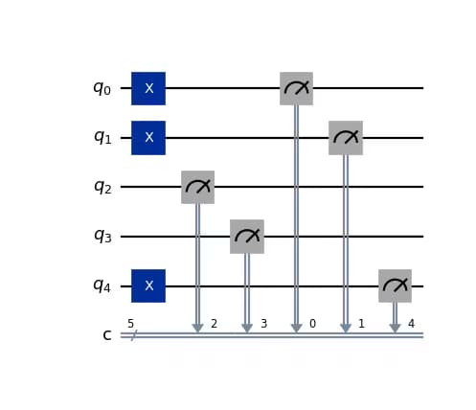
A typical QML-based phase recognition pipeline consists of:
- Quantum State Preparation
Prepare ground states of a Hamiltonian at different parameters.
- Feature Extraction Circuit
Apply a parameterized quantum circuit to probe correlations.
- Measurement
Measure observables that encode phase-dependent information.
- Classifier
Use a quantum or classical classifier to assign phase labels.

4. Simple Math Involved
- Hamiltonian family: [ H() = H_0 + H_1 ]
- Quantum state: [ |()= H() ]
- Classifier output: [ y = f_(|()) ]

5. Python Code (QML Phase Recognition – Qiskit Example)
Platform-agnostic, educational execution code
import numpy as np
from qiskit import QuantumCircuit
from qiskit.circuit.library import RealAmplitudes
from qiskit.primitives import Sampler
phases = [0.2, 1.2]
labels = [0, 1]
num_qubits = 2
ansatz = RealAmplitudes(num_qubits, reps=2)
qc = QuantumCircuit(num_qubits)
qc.compose(ansatz, inplace=True)
qc.measure_all()
sampler = Sampler()
features = []
for _ in phases:
result = sampler.run(qc, shots=512).result()
features.append(result.quasi_dists[0])
print("Extracted quantum features:", features)
print("Phase labels:", labels)

6. Where the Algorithm Is Useful
- Quantum phase recognition
- Detecting phase transitions
- Condensed matter physics
- Topological matter classification

7. Limitations
- Requires high-quality quantum state preparation
- Noise can obscure phase signatures
- Scalability is hardware-limited
- Mostly proof-of-concept today

8. Comparison with Classical Phase Classification
- Feature extraction: Hand-crafted order parameters vs learned quantum features
- Data type: Classical observables vs quantum states
- Scalability: Classical limited for many-body systems
- Maturity: Classical methods are mature; QML methods are emerging

9. One-Sentence Summary
QML for phase recognition classifies quantum phases of matter by learning patterns directly from quantum states using quantum circuits.

